USAP Assignment 2

# Report

S3485566

Note: Instead of setting up Git to the RMIT servers, I instead set it up to github. I am with the understanding that this is acceptable. https://github.com/mupg/s3485566/tree/master/s3485566-usap-a2

# Contents

User Management…………………………………………………………………………………………..

Agent Configuration…………………………………………………………………………………………

Package Management……………………………………………………………………………………..

Package Configuration……………………………………………………………………………………..

**User Management**

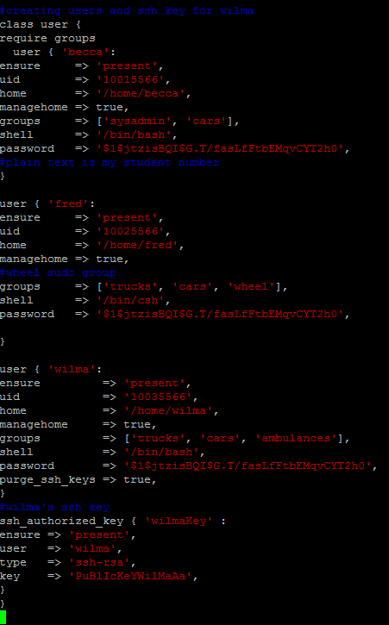

Users are created in one file with the file first requiring groups so that the users can be assigned to them. The password is my student number encrypted by using openssl -1 passwd and being inserted into the file. Fred was given the wheel group for sudo rights. The format is in accordance with Puppet-lint.

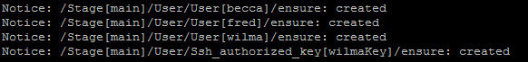 Command to initialise the code.

Users being created

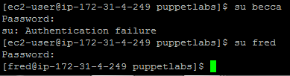

Example of incorrect password and correct password.

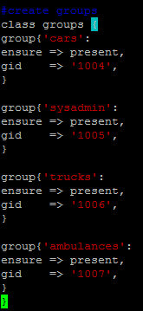Creation of groups with the group ID first being given by the system when creating user from the console. Ensure => Present creates groups.

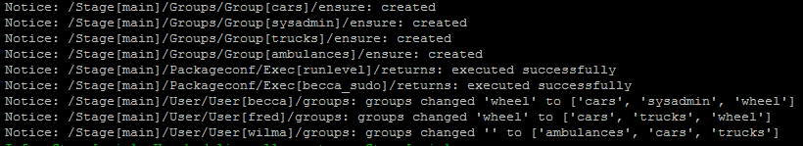

**Agent config**

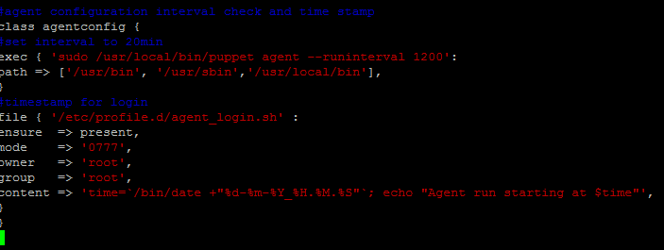

Setting up the puppet agent to check in three times per hour by using puppets agent command to set the –runinterval to 1200 seconds.

Modified the agent_login.sh file but giving them 777 permissions and root privilege and then getting the time from /bin/date and formatting it.

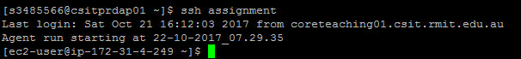

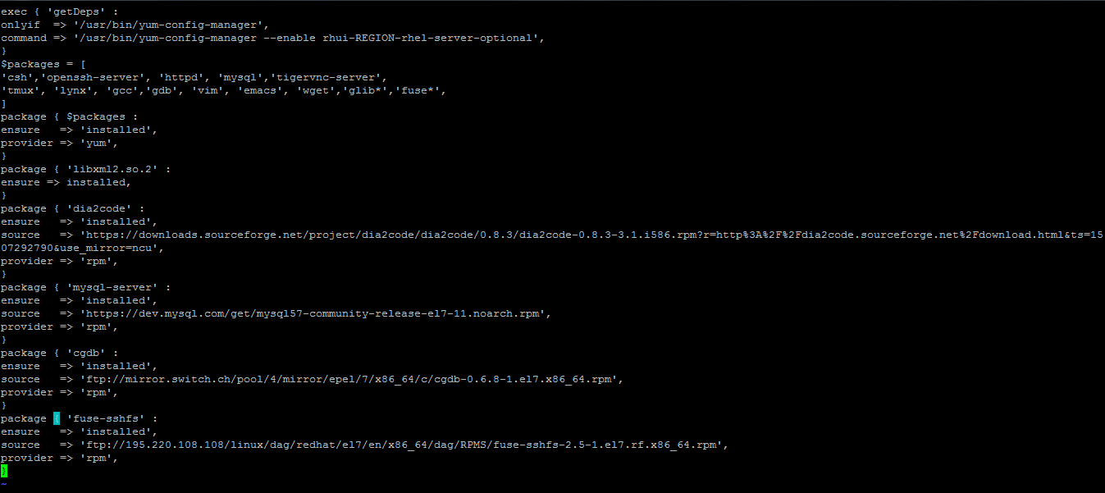**Package Creation**

Yum is limited in its packages so it was required to download a dependecy so that all downloads work properly. All packages that could be installed with yum were put into an array and installed first. Packages dia2code, mysql, cgdb and sshfs don’t exist on yum so external sources had to be found with some depencies required and all installed with rpm.



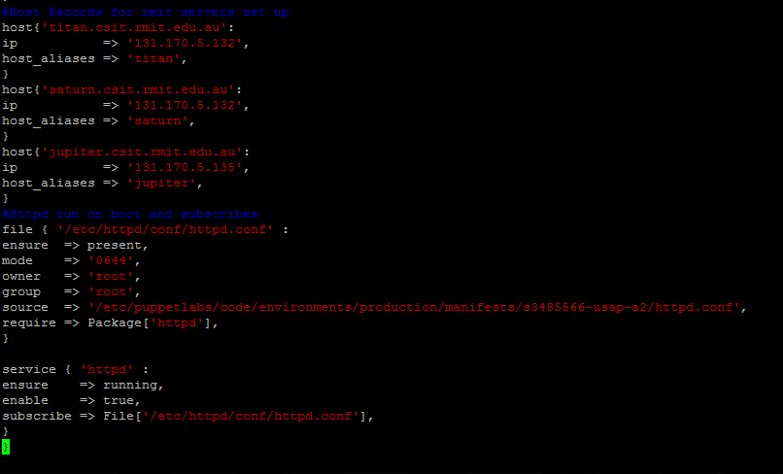**Package Management** 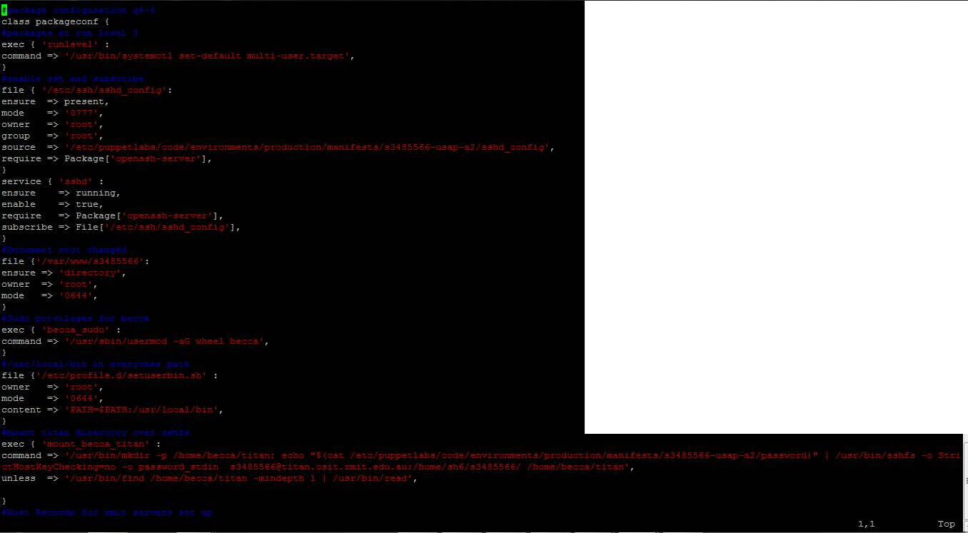

Host records were created for the internal DNS address for Titan, Jupiter and Saturn.

The Httpd.conf file is given root privileges. Httpd is then set to ensure it is running and subscribed to the httpd.conf file.

**1.**Execute a command to change the run level to 3 which for red hat is mult-user.target. **2.**The SSH file is provided to us and we give it root permissions to enable it. Then we subscribe it start on system boot and restart when changes are made to the file. **3.**Create the directory for document root to be changed too. **4.**Becca was given sudo privileges by using the usermod command. **5.**The path /usr/local/bin was added to all users. **6.**My student directory on the RMIT network was mounted to Becca’s home directory using SSHFS. To make this work the code reads a file made on the server with my password using the -o password_stdin option for SSHFS.

Nmap command was done on the localhost to show the services running on each port.

